Lab partice-3

N.vighneshwar reddy

192211784

Develop a system using UML for implementing E-Ticketing System. This is to be used by the passenger for reserving the tickets for their travel. This E-ticketing is organizedby the central system. The information is providedby the railway reservation system.

**Use case diagram**

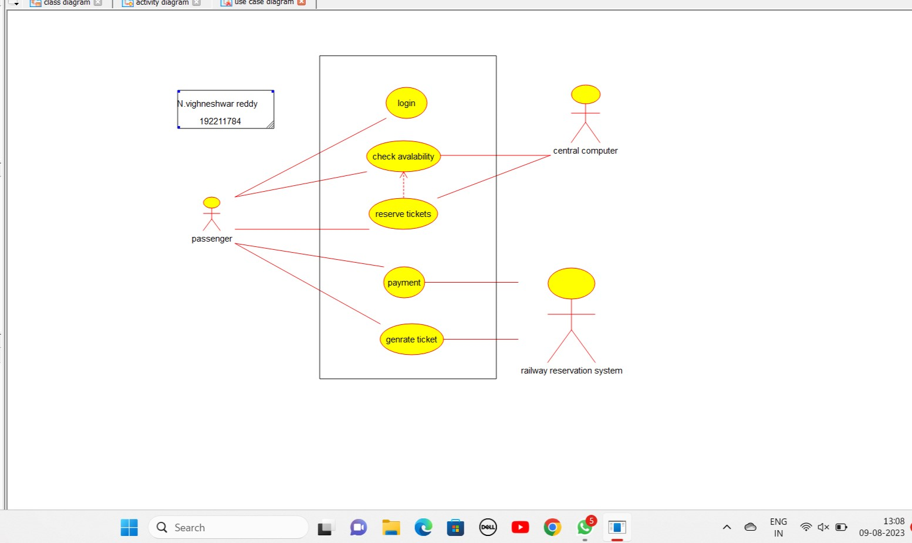

**Class diagram:**

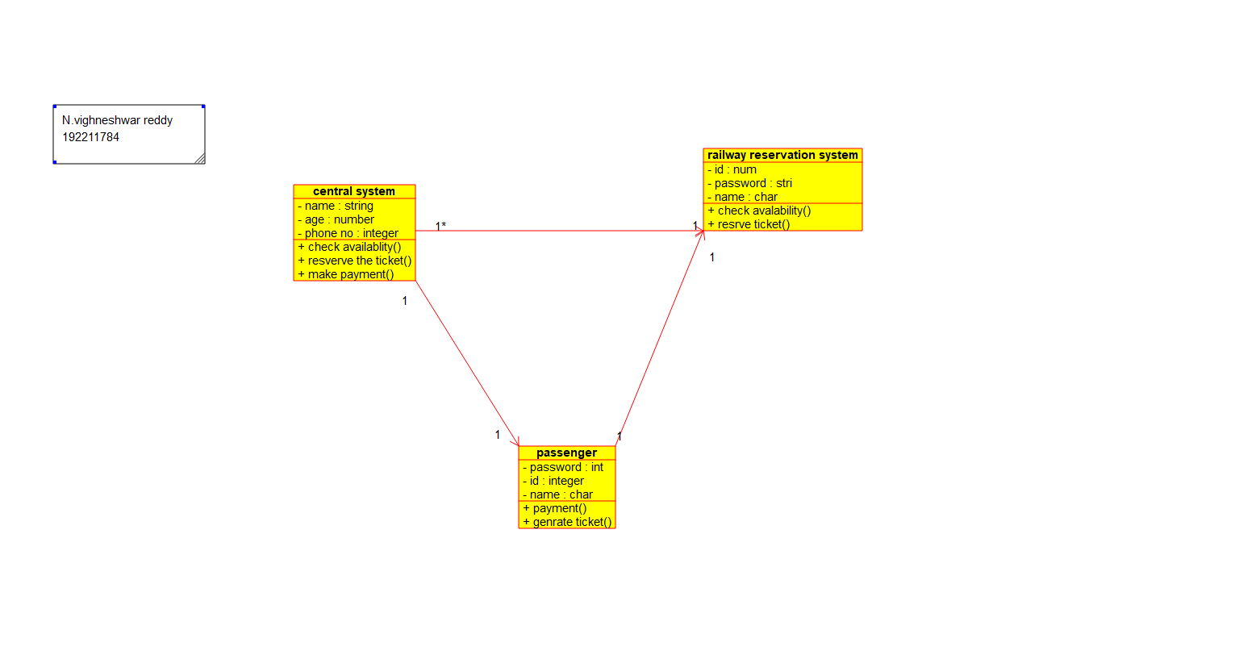

**Activity diagram:**

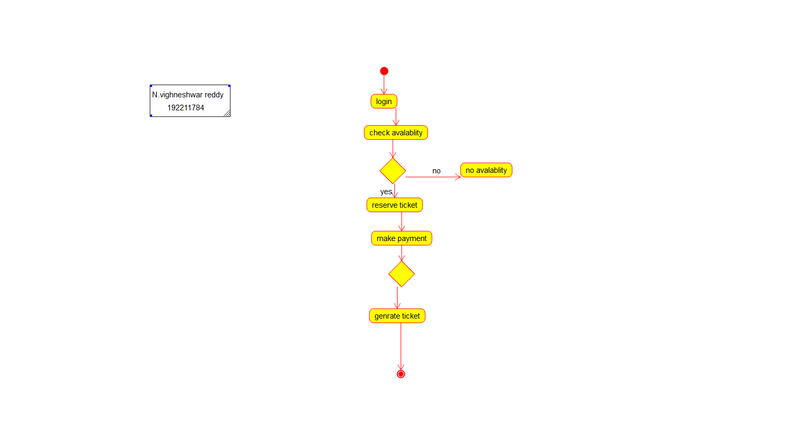

**Use case diagram:**

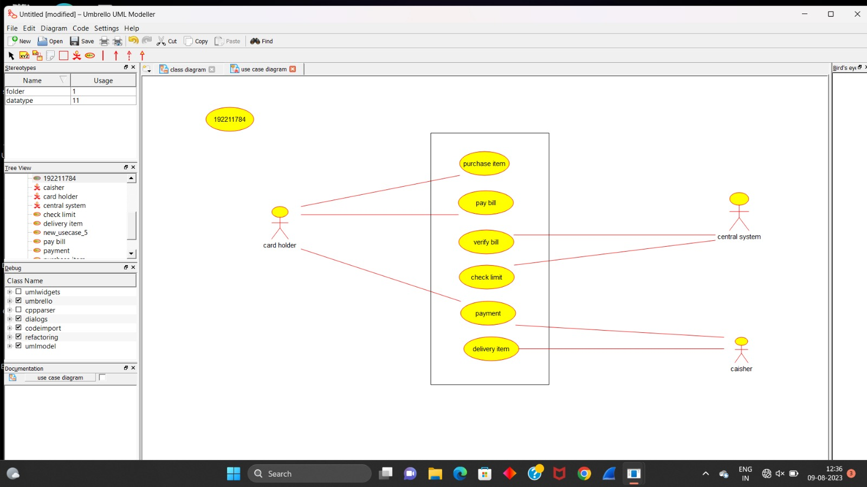

**Class diagram:**

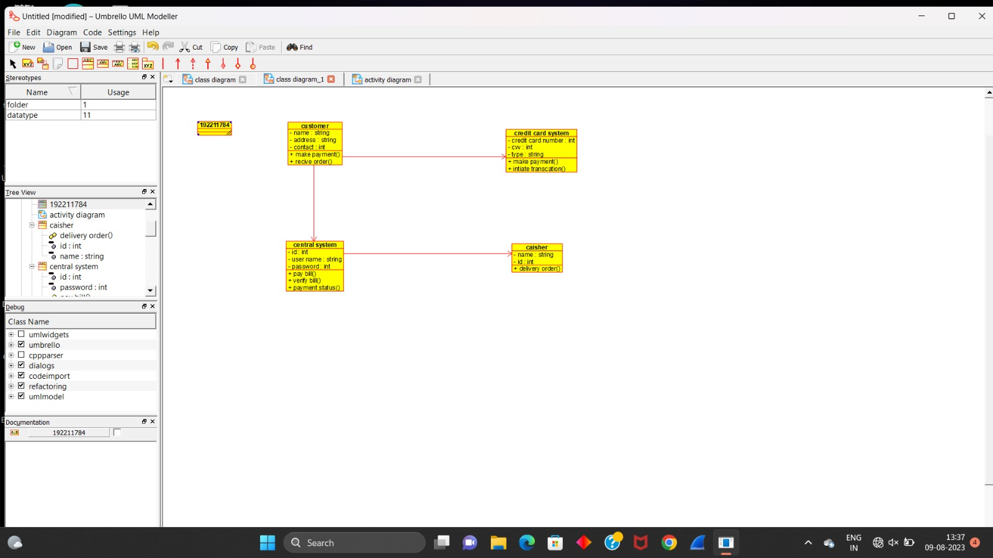

**Activity diagram:**

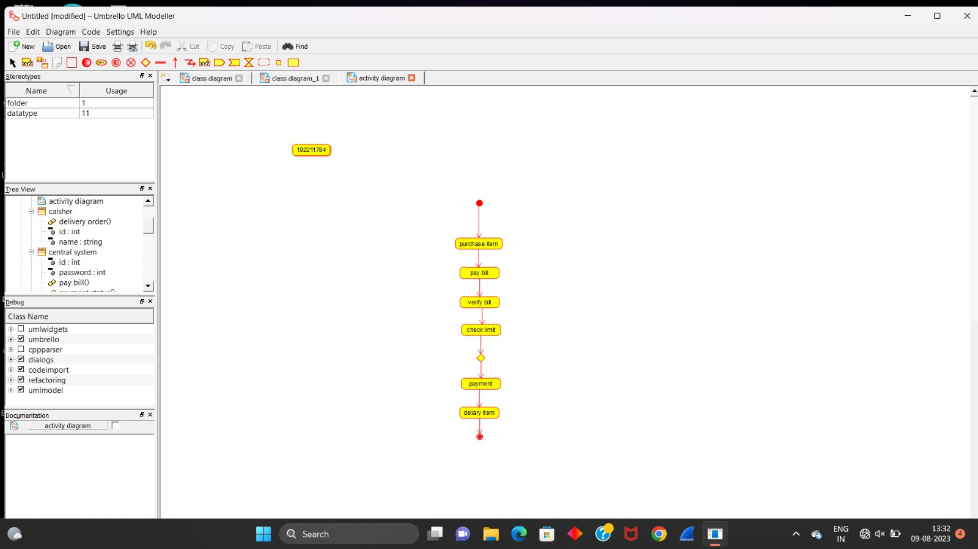

**Use case diagram:**

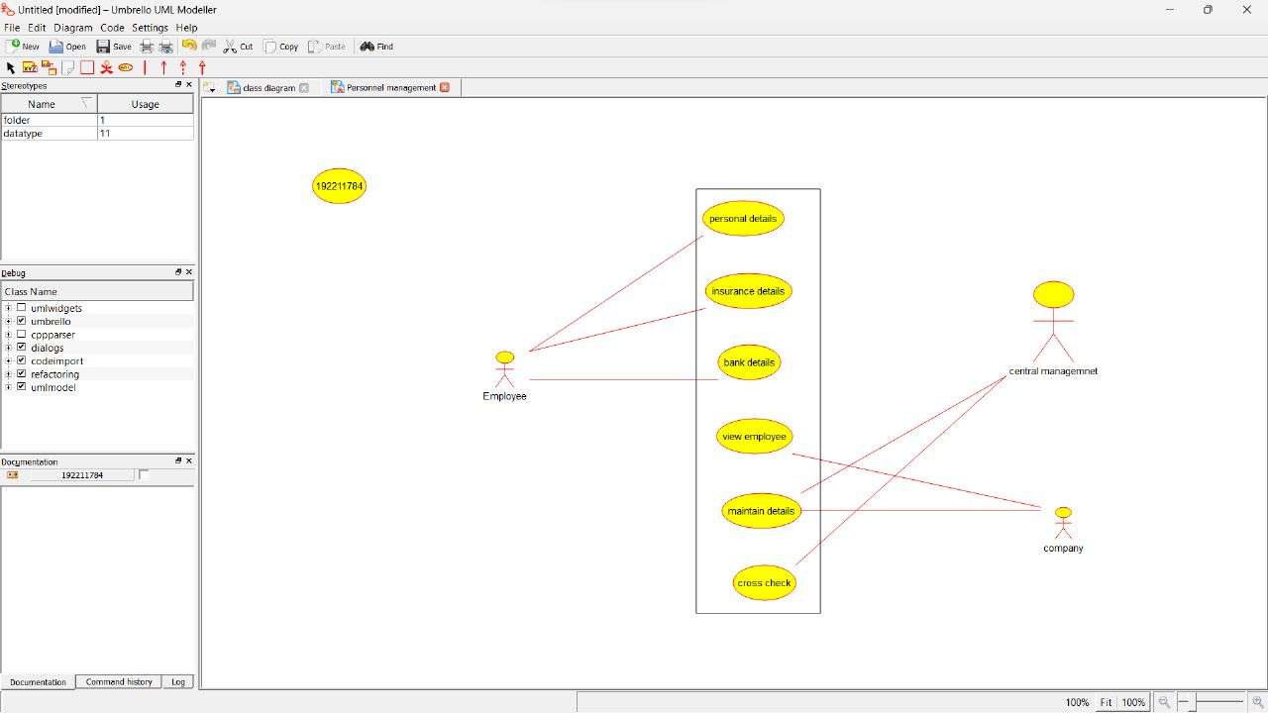

**Class diagram:**

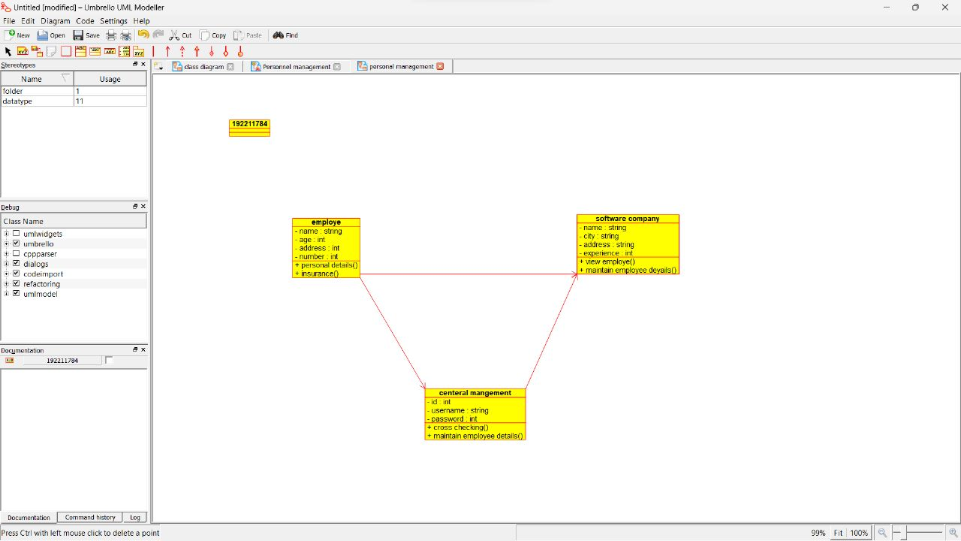

**Activity diagram:**

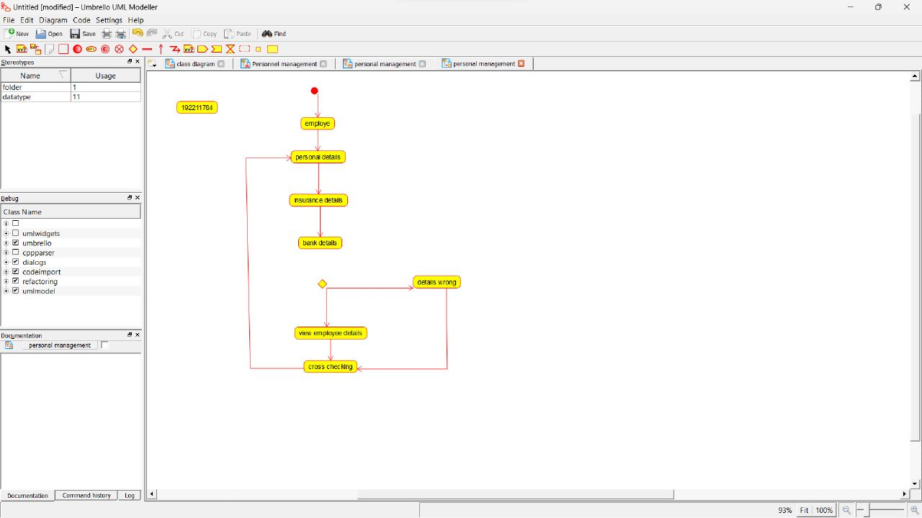

**Use case diagram:**

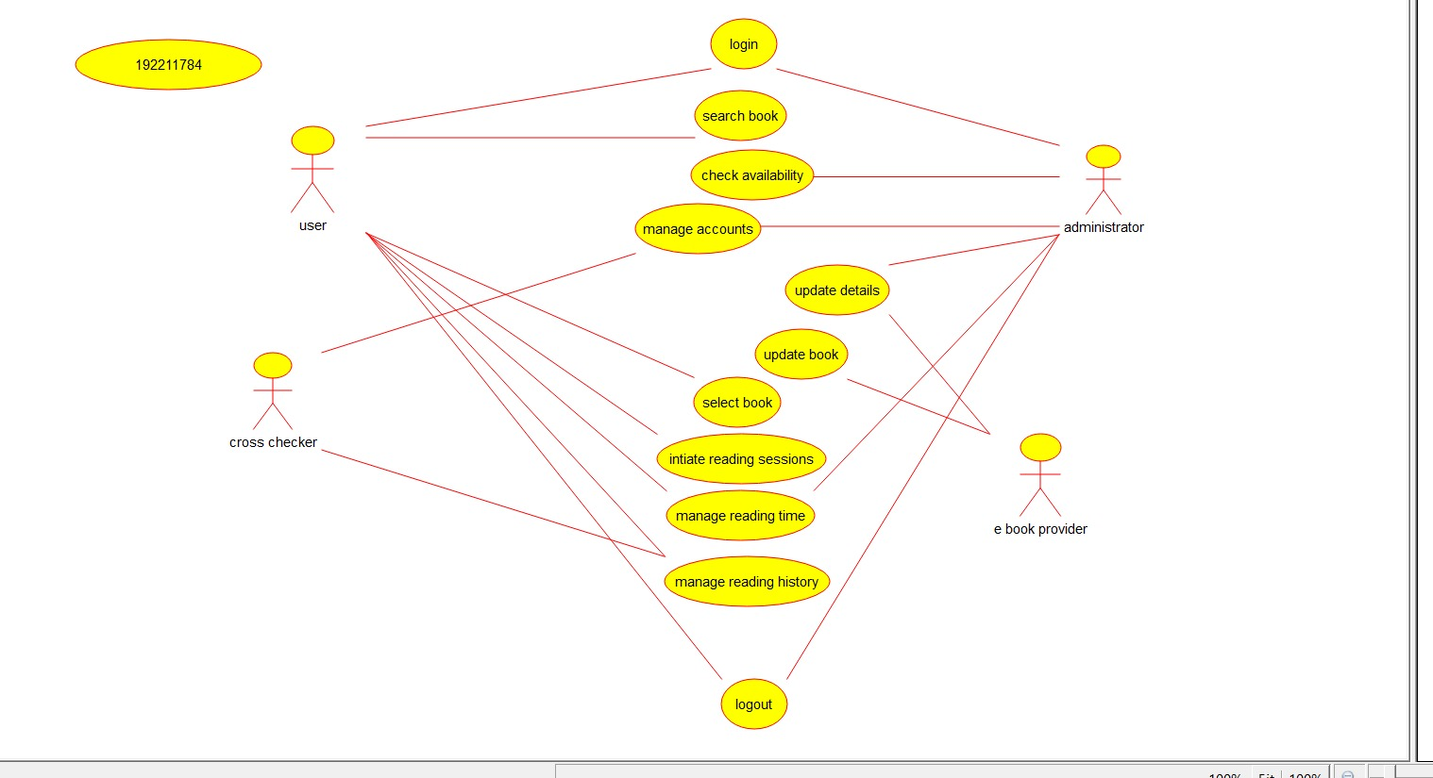

**Class diagram:**

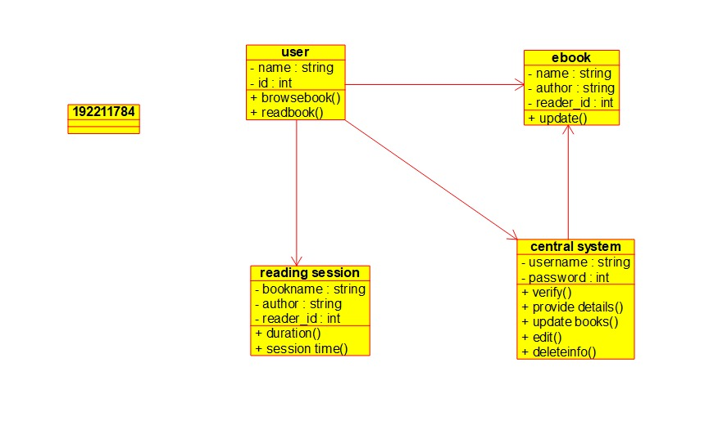

**Activity diagram:**

